Data Analytics with Tableau – Assignment 1
Team ID: LTVIP2026TMIDS25024
Bar Chart – Sales by Product Line
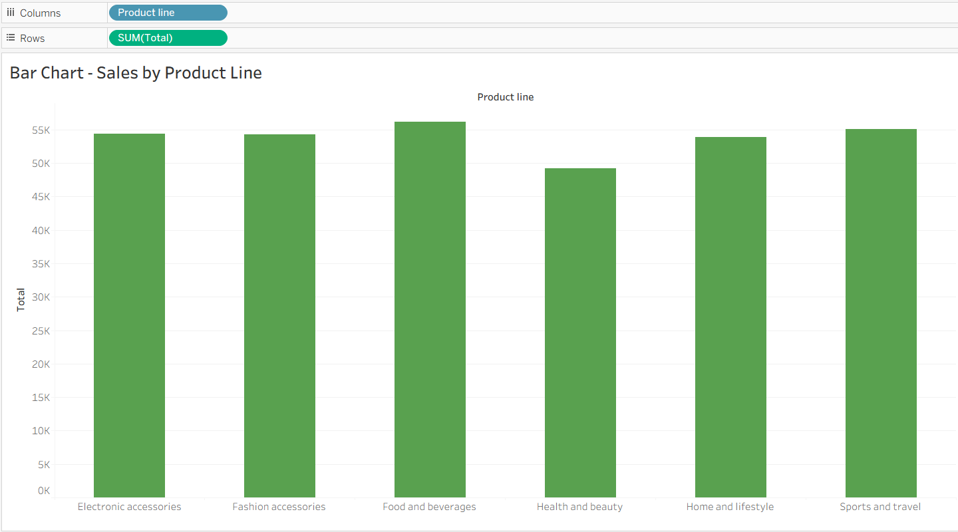

Pie Chart – Sales by Payment Method
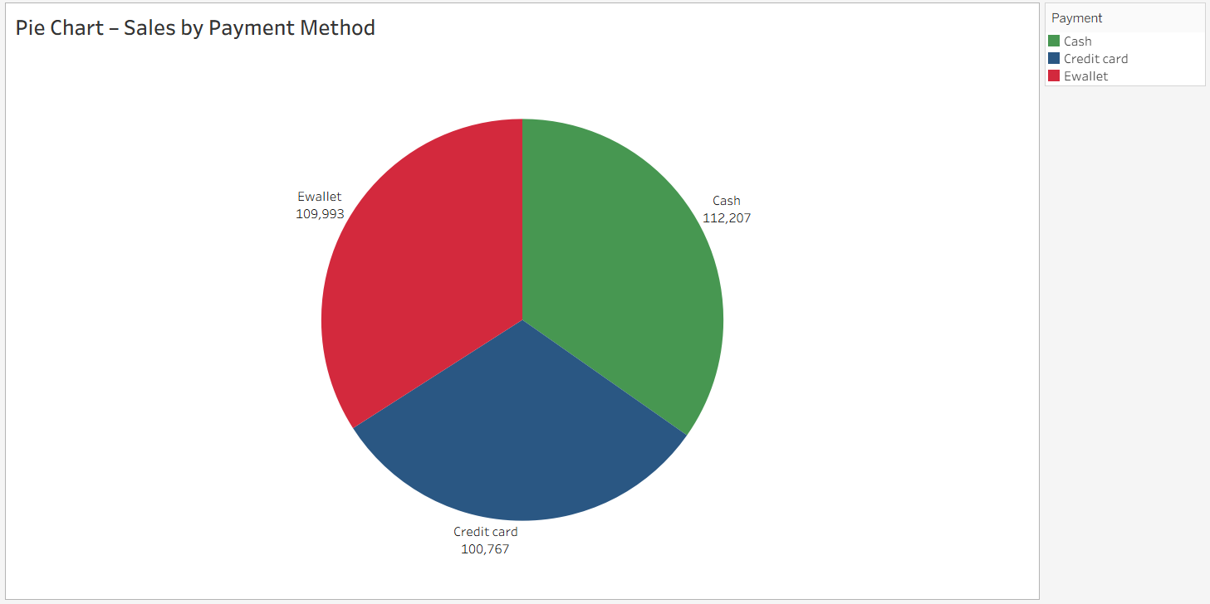

Stacked Bar Chart- Sales by Branch and Gender
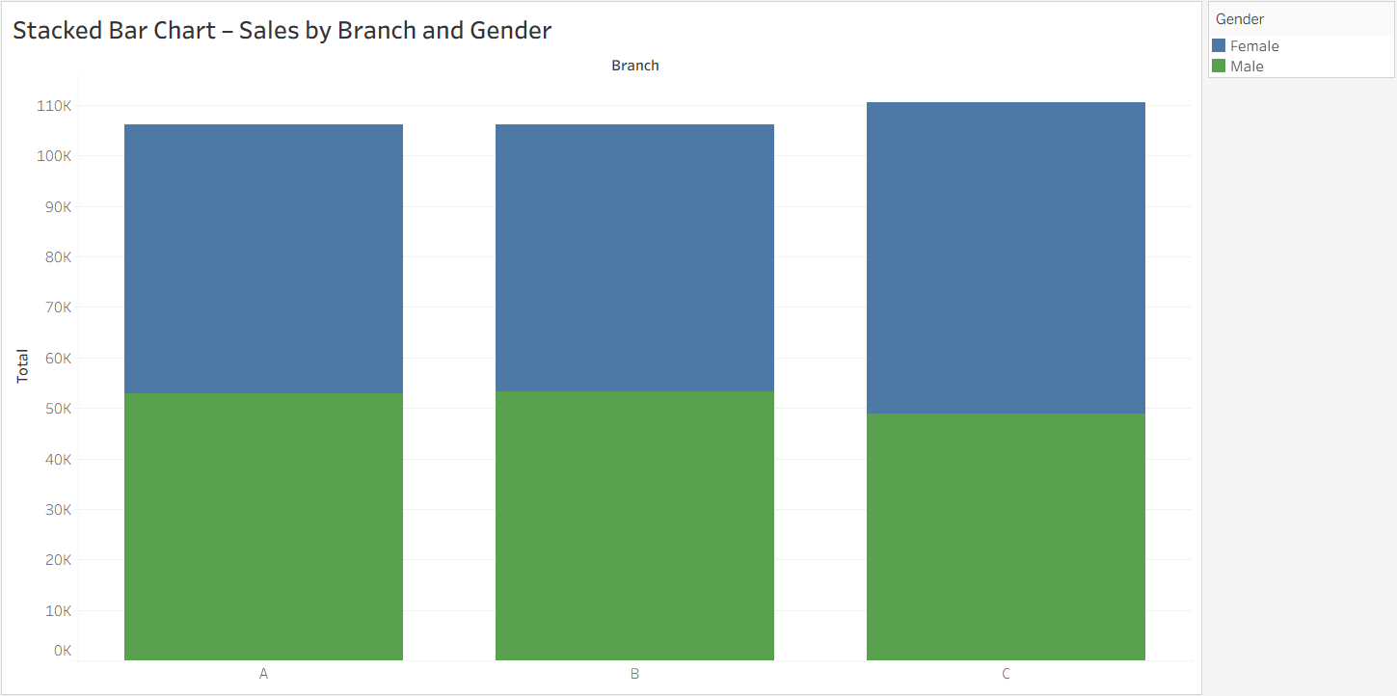

Line Chart – Sales Trend Over Time
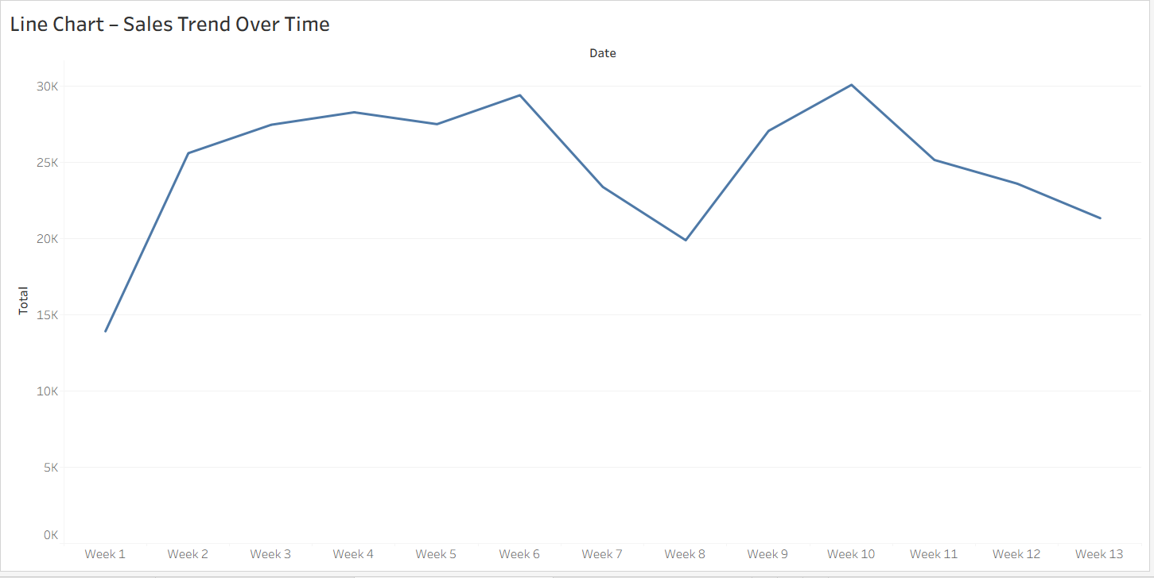

Bubble Chart – Sales by Product Line
